Given an N x N grid containing only values 0 and 1, where 0 represents water and 1 represents land, find a water cell such that its distance to the nearest land cell is maximized and return the distance.

The distance used in this problem is the *Manhattan distance*: the distance between two cells (x0, y0) and (x1, y1) is |x0 - x1| + |y0 - y1|.

If no land or water exists in the grid, return -1.

**Example 1:**

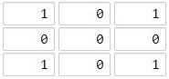

**Input:** [[1,0,1],[0,0,0],[1,0,1]]

**Output:** 2

**Explanation:**

The cell (1, 1) is as far as possible from all the land with distance 2.

**Example 2:**

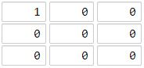

**Input:** [[1,0,0],[0,0,0],[0,0,0]]

**Output:** 4

**Explanation:**

The cell (2, 2) is as far as possible from all the land with distance 4.

**Note:**

1. 1 <= grid.length == grid[0].length <= 100
2. grid[i][j] is 0 or 1